DERIVATION OF VOLTAGE SOURCE MULTILEVEL CONVERTER TOPOLOGIES
ABSTRACT
Multilevel converters have gained popularity in both medium voltage and low voltage applications. To find out the connections between various multilevel voltagesource converter topologies and to reveal how to obtain new topologies, this paper has presented four methods to derive multilevel converter topologies. Many existing topologies as well as new topologies can be derived with the methods presented in this paper. The fundamental characteristics of the multilevel converters which determine their usability such as dc-link neutral point voltage balancing and flying capacitor voltage control are also investigated in this paper with a mathematical model and an example. It is expected that more new topologies will be invented based on the work in this paper for emerging applications.

BLOCK DIAGRAM FOR PROPOSED SYSTEM
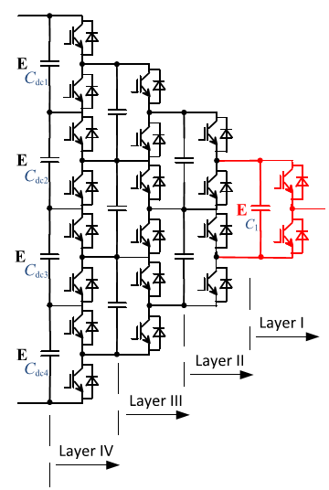
Fig. 1. Generalized topology I.
DESIGNG SOFTWARE AND TOOLS:
MAT LAB /SIMULATION Software and simu power systems tools are used. Mainly control system tools, power electronics and electrical elements tools are used.

